Data Visualization: Assignment 1

Student 1: Sofya Aksenyuk, 150284

Student 2: Uladzimir Ivashka, 150281

# Original image

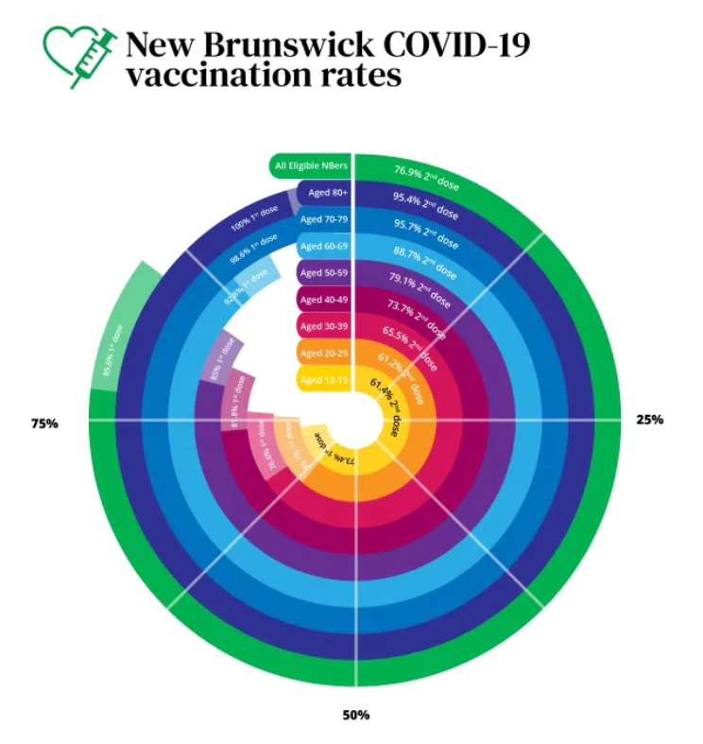

URL: https://www.cbc.ca/amp/1.6173430

Context: New Brunswick COVID-19 vaccination rates.

Story behind: New Brunswick has recorded a big bump in positive COVID-19 cases related to Campbellton and Moncton clusters, with multiple schools and daycares closed on Monday.

Faults:

* Incorrect chart type choice
* Difficulties in presented data comparison
* Unproportional scaling (caused by data types (first and second dose) combining)
* Need of the chart rotation to read data

Implications:

* Inaccurate understanding of the data
* Unusefulness of such data visualization
* Incorrect insights

Possible improvements:

* Choosing different chart type (e.g., bar chart)
* Highlighting the group with the highest and lowest values
* Separation of data types (first and second dose)

# Sketch

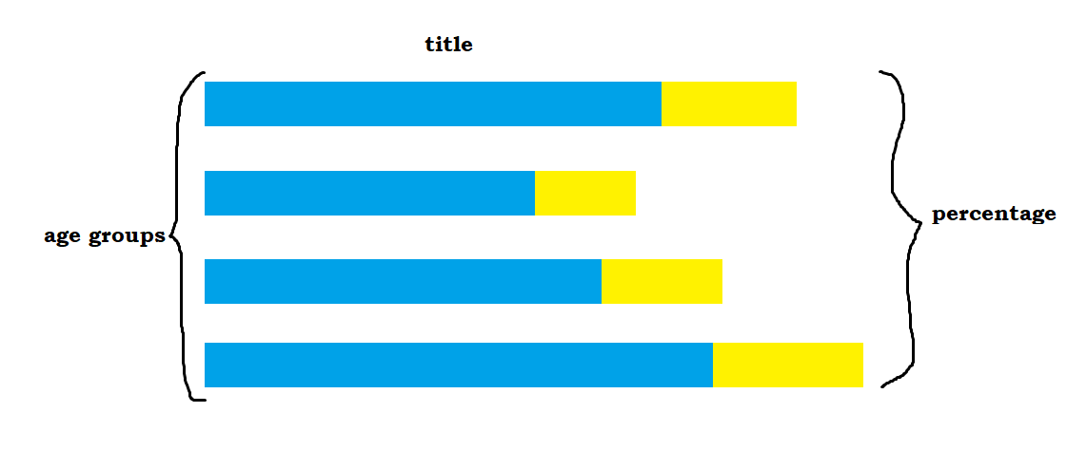

# Implementation

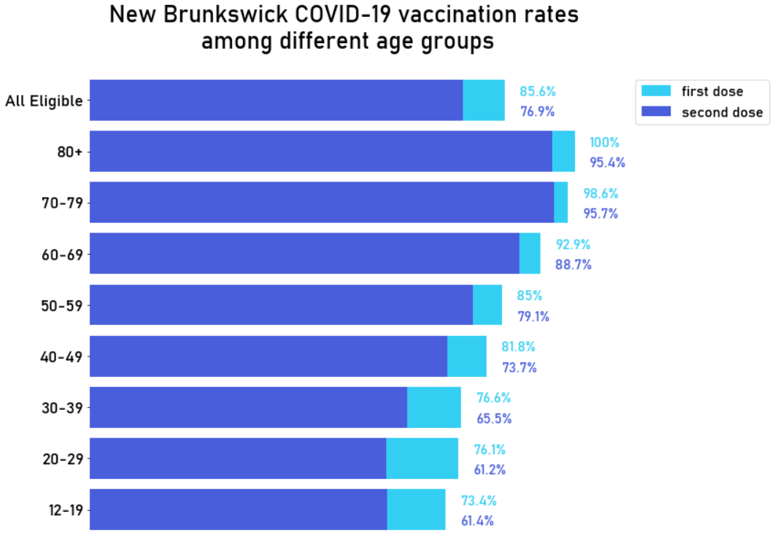

# Implementation code

